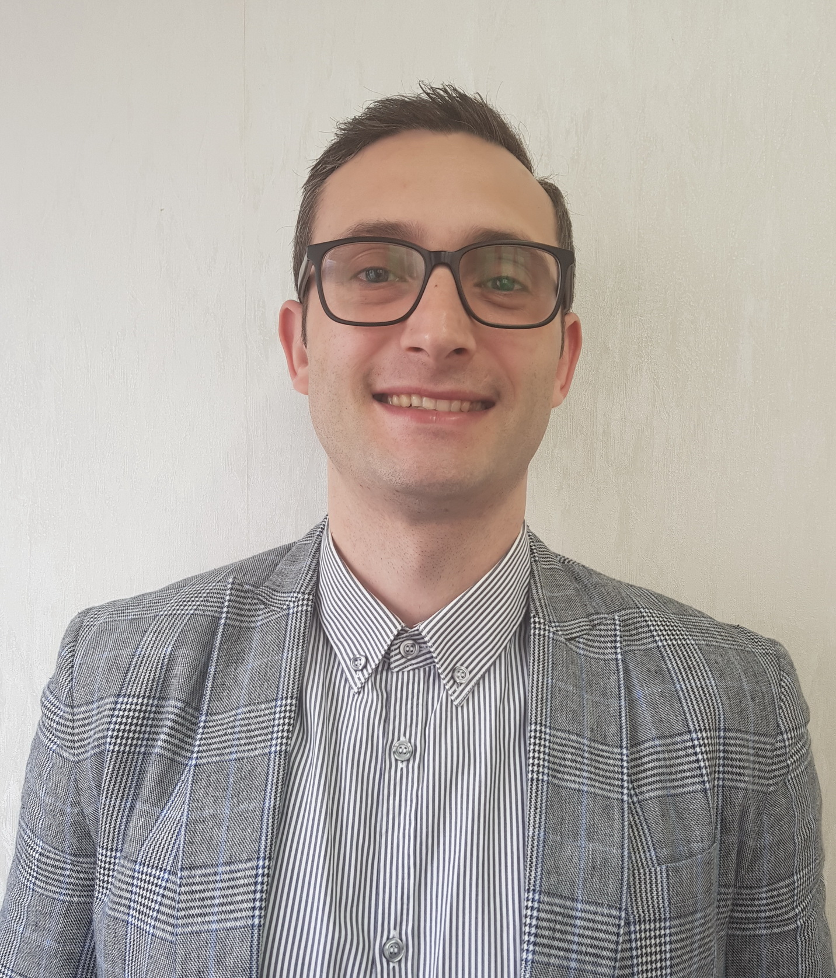

**Energetic, hard worker and highly motivated bartender with 15 years international Bar tending experience and solid knowledge of classical cocktails.**

**Get along well with management, co-workers and customers. Well-developed communication skills, known as caring and intuitive “people person”, with an upbeat and positive attitude. Highly flexible, honest and punctual, with the ability to stay calm and focused in stressful situations.**

**Committed to a job well done and interested in a rewarding long-term career.**

|  |  |
| --- | --- |
|  | **Cristian Cioboata**  **3rd District, Bucharest**  **cristiancioboata21@yahoo.com**  **+40 770485093** |

OUTSTANDING ACHIEVMENTS

* Extensive employment history on 5* cruiseships, hotels and clubs around the world serving to a capacity of 2,500 people
* Served notable VIP clientele
* History of repeat and new customers requesting my service
* Known for creating atmosphere of enjoyment and pleasure to the customer
* I was on training for one month in Dubai for 2LIV Night Club by Sofitel
* I have done trainings for Wines, Cocktails and Coffees
* I had training for the Ivy Collection as a cocktail Bartender
* I had many trainings provided by the Royal Caribbean Cruise Line
* I have created many cocktails menus

OVERALL RESPONSABILITIES

**BARTENDING & CUSTOMER SERVICE**

* Preparing and serving cocktails, champagnes, wines, beers, prossecco, soft drinks, juices, smoothies and coffees & teas
* bar visual merchandising and organizing the cellar.
* Maintaining the condition of beer and wine
* Dealing with difficult customers
* Make sure all cleaning and break down is done to the correct standard and signed off

**MANAGEMENT:**

* Daily stockmanagement/ inventory and ordering as necessary from suppliers

refill refridgeritors

* Supervising and coordinating the Baverage team to perform a very good activity and to satisfy all needs of the guests.
* Recruiting, training and motivating staff
* Handling deliveries
* Enforcing health and safety rules
* Adhering to budgets, increasing profits and managing cashflow
* Delegate jobs and check that all staff understand their responsibilities
* Deal with any equipment break-downs
* Ensure there is adequate change in the tills
* Fully understand the operation, administration and reporting of till and pdq systems
* Cash control and end of day cash up
* Write and send end of day supervisor reports
* Authorise and record wastage
* Created a new menu with cocktails

RELATED WORK EXPERIENCE

* **London Experience - After The Ivy and before I was working with 2 agencies that provide me temporary jobs all over London. I was working with them for: Roof Gardens, Crazy Bear, Piccadilly Institute, Amber Club, Coppa Club, Hilton, All-star Lanes, Oslo Court Restaurant and Gaucho.**
* **Sensio – Bucharest –** October 2018 – **Cocktail Bartender**
* **The Ivy Collection Brasserie - Kings Cross – London** October 2017 – April 2018, ***Cocktail Bartender***
* **Gallery Mess – Saatchi gallery, Chelsea, London** April 2017 – September 2017, ***Bartender***
* **The Fulwood Bar&Kittchen- Holborn- London**  January 2016 – March 2017, **Head Bartender**
* **Royal Caribbean Cruise – Explorer of the Seas – American Company for cruise ships,** March 2015 – October 2015, ***Bartender***
* **Club Chaboo, Bucharest**  June 2014 - February 2015, ***Head Bartender***
* **2Liv Night Club by Hotel Sofitel Luxury Resort and Spa, Dubai ,** August 2013 – May 2014, Bartender
* **Club Bamboo and BonTon , Bucharest** October 2003 – June 2013, Bartender

**Academic Background**

**BA Faculty of Agrifood and Environment,**

Academy of Economic Studies Bucharest, **2001**-2006

**Interests**

I like maintaining my body, strength and health by going to the gym and swimming

**REFERENCES AVAILABLE UPON REQUEST**